IT24100170

Lab 06

01.

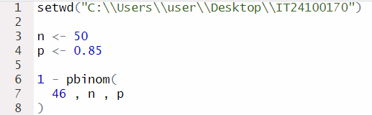

02.

